COMP 6751 Natural Language Analysis

Project Report 2 **(Demo):**

***Developing Context Free Grammar***

Student name: Md Sakib Ullah Sourav

ID: 40264066

*Expectations of originality:*

*I, Md Sakib Ullah Sourav (student id 40264066), certify that this submission is my original work and meets the Faculty’s Expectations of Originality.*

*Date: October 12, 2023*

Contents

1. Test Scenarios in Validation Data 3

1.1 Test Scenario 1 3

1.2. Test Scenario 2 5

1.3 Test Scenario 3 11

1.4 Test Scenario 4 15

1.5 Test Scenario 5 22

1.6 Test Scenario 6 23

1.7 Test Scenario 7 24

2. Outputs in CoNLL Format 33

3. Limitations 37

# **Test Scenarios in Validation Data**

(To access to my entire code, please visit this link- [*https://drive.google.com/file/d/1ps0xa8tx5Zhc_6lke1kPFBuC3Jz_sk8r/view?usp=sharing*](https://drive.google.com/file/d/1ps0xa8tx5Zhc_6lke1kPFBuC3Jz_sk8r/view?usp=sharing)

And, let me know if the link is not working!)

The validation data has been placed into the code as below

input = [

    "John ate the apple at the table.",

    "John, who ate the apple from the fridge, was sick Wednesday.",

    "On Monday, John ate the apple in his office.",

    "Last week, on Monday, John finally took the apple from the fridge to his office.",

    "Heart rate greater than 90 beats/minute",

    "Body temperature over 38 or under 36 degrees Celsius.",

    "Respiratory rate greater than 20 breaths/minute or partial pressure   
 of CO2 less than 32 mmHg",

    "Leukocyte count greater than 12000 or less than 4000 /microliters or   
 over 10% immature forms or bands."

  ]

## **1.1 Test Scenario 1**

Input: John ate the apple at the table.

Result: The proofreading results and text preprocess pipeline can be delivered, and the   
 programme can operate correctly. Earley parse process results are displayed below.

1

John ate the apple at the table

S

____________|________

S |

________|___ |

| VP PP

| _______|___ ___|___

| | NP | NP

| | ___|____ | ___|____

NP | | NP | | NP

| | | | | | |

PropN V | N | | N

| | | | | | |

NNP VBD DT NN IN DT NN

| | | | | | |

John ate the apple at the table

S

____|____________

| VP

| ________|________

| VP PP

| ___|___ ___|___

| | NP | NP

| | ___|____ | ___|____

NP | | NP | | NP

| | | | | | |

PropN V | N | | N

| | | | | | |

NNP VBD DT NN IN DT NN

| | | | | | |

John ate the apple at the table

S

____|____________

| VP

| ____________|____

| | NP

| | _________|___

| | | PP

| | | ___|___

| | NP | NP

| | ___|____ | ___|____

NP | | NP | | NP

| | | | | | |

PropN V | N | | N

| | | | | | |

NNP VBD DT NN IN DT NN

| | | | | | |

John ate the apple at the table

S

____|________

| VP

| ________|____

| | NP

| | _________|___

| | | NP

| | | ________|___

| | | | PP

| | | | _______|___

| | | | | NP

| | | | | ___|____

NP | | NP | | NP

| | | | | | |

PropN V | N | | N

| | | | | | |

NNP VBD DT NN IN DT NN

| | | | | | |

John ate the apple at the table

S

____|____________

| VP

| ____________|________

| | | PP

| | | ___|___

| | NP | NP

| | ___|____ | ___|____

NP | | NP | | NP

| | | | | | |

PropN V | N | | N

| | | | | | |

NNP VBD DT NN IN DT NN

| | | | | | |

John ate the apple at the table

## **1.2. Test Scenario 2**

Input: John, who ate the apple from the fridge, was sick Wednesday.

Result: The proofreading results and text preprocess pipeline can be delivered, and the   
 programme can operate correctly. Earley parse process results are displayed below.

S

_______________________________|_________________________________

| S | |

| ________|__________________ | |

| S | | |

| _________|________ | | |

| | | | VP PP | S

| | | | ___|___ ____|___ | |

| | | | | NP | NP | NP

| | | | | ___|____ | ___|____ | ____|______

| | NP NP | | NP | | NP | | NP

| | | | | | | | | | | | |

| | PropN ProN V | N | | N V ADJ PropN

| | | | | | | | | | | | |

| | NNP WP VBD DT NN IN DT NN VBD JJ NNP

| | | | | | | | | | | | |

, , John who ate the apple from the fridge was sick Wednesday

S

_______________________________|_________________________________

| S | |

| __________________|________ | |

| | | | VP | |

| | | | ________|_________ | |

| | | | VP PP | S

| | | | ___|___ ____|___ | |

| | | | | NP | NP | NP

| | | | | ___|____ | ___|____ | ____|______

| | NP NP | | NP | | NP | | NP

| | | | | | | | | | | | |

| | PropN ProN V | N | | N V ADJ PropN

| | | | | | | | | | | | |

| | NNP WP VBD DT NN IN DT NN VBD JJ NNP

| | | | | | | | | | | | |

, , John who ate the apple from the fridge was sick Wednesday

S

_______________________________|_________________________________

| S | |

| __________________|________ | |

| | | | VP | |

| | | | ____________|____ | |

| | | | | NP | |

| | | | | _________|____ | |

| | | | | | PP | S

| | | | | | ____|___ | |

| | | | | NP | NP | NP

| | | | | ___|____ | ___|____ | ____|______

| | NP NP | | NP | | NP | | NP

| | | | | | | | | | | | |

| | PropN ProN V | N | | N V ADJ PropN

| | | | | | | | | | | | |

| | NNP WP VBD DT NN IN DT NN VBD JJ NNP

| | | | | | | | | | | | |

, , John who ate the apple from the fridge was sick Wednesday

S

___________________________|_____________________________________

| S | |

| __________________|____ | |

| | | | VP | |

| | | | ________|____ | |

| | | | | NP | |

| | | | | _________|____ | |

| | | | | | NP | |

| | | | | | _________|___ | |

| | | | | | | PP | S

| | | | | | | ________|___ | |

| | | | | | | | NP | NP

| | | | | | | | ___|____ | ____|______

| | NP NP | | NP | | NP | | NP

| | | | | | | | | | | | |

| | PropN ProN V | N | | N V ADJ PropN

| | | | | | | | | | | | |

| | NNP WP VBD DT NN IN DT NN VBD JJ NNP

| | | | | | | | | | | | |

, , John who ate the apple from the fridge was sick Wednesday

S

_______________________________|_________________________________

| S | |

| __________________|________ | |

| | | | VP | |

| | | | ____________|_________ | |

| | | | | | PP | S

| | | | | | ____|___ | |

| | | | | NP | NP | NP

| | | | | ___|____ | ___|____ | ____|______

| | NP NP | | NP | | NP | | NP

| | | | | | | | | | | | |

| | PropN ProN V | N | | N V ADJ PropN

| | | | | | | | | | | | |

| | NNP WP VBD DT NN IN DT NN VBD JJ NNP

| | | | | | | | | | | | |

, , John who ate the apple from the fridge was sick Wednesday

S

_______________________________|____________________________

| | | | VP |

| | | | ________|_________ |

| | | | VP PP VP

| | | | ___|___ ____|___ ___|____

| | | | | NP | NP | NP

| | | | | ___|____ | ___|____ | ____|______

| | NP NP | | NP | | NP | | NP

| | | | | | | | | | | | |

| | PropN ProN V | N | | N V ADJ PropN

| | | | | | | | | | | | |

| | NNP WP VBD DT NN IN DT NN VBD JJ NNP

| | | | | | | | | | | | |

, , John who ate the apple from the fridge was sick Wednesday

S

_______________________________|____________________________

| | | | VP |

| | | | ____________|____ |

| | | | | NP |

| | | | | _________|____ |

| | | | | | PP VP

| | | | | | ____|___ ___|____

| | | | | NP | NP | NP

| | | | | ___|____ | ___|____ | ____|______

| | NP NP | | NP | | NP | | NP

| | | | | | | | | | | | |

| | PropN ProN V | N | | N V ADJ PropN

| | | | | | | | | | | | |

| | NNP WP VBD DT NN IN DT NN VBD JJ NNP

| | | | | | | | | | | | |

, , John who ate the apple from the fridge was sick Wednesday

S

___________________________|________________________________

| | | | VP |

| | | | ________|____ |

| | | | | NP |

| | | | | _________|____ |

| | | | | | NP |

| | | | | | _________|___ |

| | | | | | | PP VP

| | | | | | | ________|___ ___|____

| | | | | | | | NP | NP

| | | | | | | | ___|____ | ____|______

| | NP NP | | NP | | NP | | NP

| | | | | | | | | | | | |

| | PropN ProN V | N | | N V ADJ PropN

| | | | | | | | | | | | |

| | NNP WP VBD DT NN IN DT NN VBD JJ NNP

| | | | | | | | | | | | |

, , John who ate the apple from the fridge was sick Wednesday

S

_______________________________|____________________________

| | | | VP |

| | | | ____________|_________ |

| | | | | | PP VP

| | | | | | ____|___ ___|____

| | | | | NP | NP | NP

| | | | | ___|____ | ___|____ | ____|______

| | NP NP | | NP | | NP | | NP

| | | | | | | | | | | | |

| | PropN ProN V | N | | N V ADJ PropN

| | | | | | | | | | | | |

| | NNP WP VBD DT NN IN DT NN VBD JJ NNP

| | | | | | | | | | | | |

, , John who ate the apple from the fridge was sick Wednesday

S

_______________________________|____________________________

| | | | VP |

| | | | ________|_________ |

| | | | VP PP |

| | | | ___|___ ____|___ |

| | | | | NP | NP VP

| | | | | ___|____ | ___|____ ___|_______

| | NP NP | | NP | | NP | | NP

| | | | | | | | | | | | |

| | PropN ProN V | N | | N V ADJ PropN

| | | | | | | | | | | | |

| | NNP WP VBD DT NN IN DT NN VBD JJ NNP

| | | | | | | | | | | | |

, , John who ate the apple from the fridge was sick Wednesday

S

_______________________________|____________________________

| | | | VP |

| | | | ____________|____ |

| | | | | NP |

| | | | | _________|____ |

| | | | | | PP |

| | | | | | ____|___ |

| | | | | NP | NP VP

| | | | | ___|____ | ___|____ ___|_______

| | NP NP | | NP | | NP | | NP

| | | | | | | | | | | | |

| | PropN ProN V | N | | N V ADJ PropN

| | | | | | | | | | | | |

| | NNP WP VBD DT NN IN DT NN VBD JJ NNP

| | | | | | | | | | | | |

, , John who ate the apple from the fridge was sick Wednesday

S

___________________________|________________________________

| | | | VP |

| | | | ________|____ |

| | | | | NP |

| | | | | _________|____ |

| | | | | | NP |

| | | | | | _________|___ |

| | | | | | | PP |

| | | | | | | ________|___ |

| | | | | | | | NP VP

| | | | | | | | ___|____ ___|_______

| | NP NP | | NP | | NP | | NP

| | | | | | | | | | | | |

| | PropN ProN V | N | | N V ADJ PropN

| | | | | | | | | | | | |

| | NNP WP VBD DT NN IN DT NN VBD JJ NNP

| | | | | | | | | | | | |

, , John who ate the apple from the fridge was sick Wednesday

S

_______________________________|____________________________

| | | | VP |

| | | | ____________|_________ |

| | | | | | PP |

| | | | | | ____|___ |

| | | | | NP | NP VP

| | | | | ___|____ | ___|____ ___|_______

| | NP NP | | NP | | NP | | NP

| | | | | | | | | | | | |

| | PropN ProN V | N | | N V ADJ PropN

| | | | | | | | | | | | |

| | NNP WP VBD DT NN IN DT NN VBD JJ NNP

| | | | | | | | | | | | |

, , John who ate the apple from the fridge was sick Wednesday

## **1.3 Test Scenario 3**

Input: On Monday, John ate the apple in his office.

Result: The proofreading results and text preprocess pipeline can be delivered, and the   
 programme can operate correctly. Earley parse process results are displayed below.

1

On Monday, John ate the apple in his office

S

____|_________________________

S |

___________________|________ |

| | S |

| | ________|___ |

| | | VP PP

| | | _______|___ ___|___

| PP | | NP | NP

| ___|____ | | ___|____ | ___|____

| | NP NP | | NP | | NP

| | | | | | | | | |

| | PropN PropN V | N | ADJ N

| | | | | | | | | |

| IN NNP NNP VBD DT NN IN JJ NN

| | | | | | | | | |

, on Monday John ate the apple in his office

S

________________________|________________

| | S

| | ____________|________

| | S |

| | ________|___ |

| | | VP PP

| | | _______|___ ___|___

| PP | | NP | NP

| ___|____ | | ___|____ | ___|____

| | NP NP | | NP | | NP

| | | | | | | | | |

| | PropN PropN V | N | ADJ N

| | | | | | | | | |

| IN NNP NNP VBD DT NN IN JJ NN

| | | | | | | | | |

, on Monday John ate the apple in his office

S

___|____________________

| | S

| | ____|____________

| | | VP

| | | ________|________

| | | VP PP

| | | ___|___ ___|___

| PP | | NP | NP

| ___|____ | | ___|____ | ___|____

| | NP NP | | NP | | NP

| | | | | | | | | |

| | PropN PropN V | N | ADJ N

| | | | | | | | | |

| IN NNP NNP VBD DT NN IN JJ NN

| | | | | | | | | |

, on Monday John ate the apple in his office

S

___|____________________

| | S

| | ____|____________

| | | VP

| | | ____________|____

| | | | NP

| | | | _________|___

| | | | | PP

| | | | | ___|___

| PP | | NP | NP

| ___|____ | | ___|____ | ___|____

| | NP NP | | NP | | NP

| | | | | | | | | |

| | PropN PropN V | N | ADJ N

| | | | | | | | | |

| IN NNP NNP VBD DT NN IN JJ NN

| | | | | | | | | |

, on Monday John ate the apple in his office

S

___|____________________

| | S

| | ____|________

| | | VP

| | | ________|____

| | | | NP

| | | | _________|___

| | | | | NP

| | | | | ________|___

| | | | | | PP

| | | | | | _______|___

| PP | | | | | NP

| ___|____ | | | | | ___|____

| | NP NP | | NP | | NP

| | | | | | | | | |

| | PropN PropN V | N | ADJ N

| | | | | | | | | |

| IN NNP NNP VBD DT NN IN JJ NN

| | | | | | | | | |

, on Monday John ate the apple in his office

S

___|____________________

| | S

| | ____|____________

| | | VP

| | | ____________|________

| | | | | PP

| | | | | ___|___

| PP | | NP | NP

| ___|____ | | ___|____ | ___|____

| | NP NP | | NP | | NP

| | | | | | | | | |

| | PropN PropN V | N | ADJ N

| | | | | | | | | |

| IN NNP NNP VBD DT NN IN JJ NN

| | | | | | | | | |

, on Monday John ate the apple in his office

## **1.4 Test Scenario 4**

Input: Last week, on Monday, John finally took the apple from the fridge to his office.

Result: The proofreading results and text preprocess pipeline can be delivered, and the   
 programme can operate correctly. Earley parse process results are displayed below.

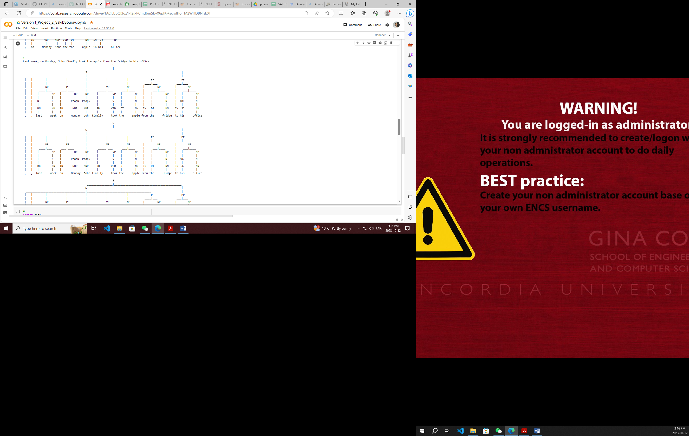

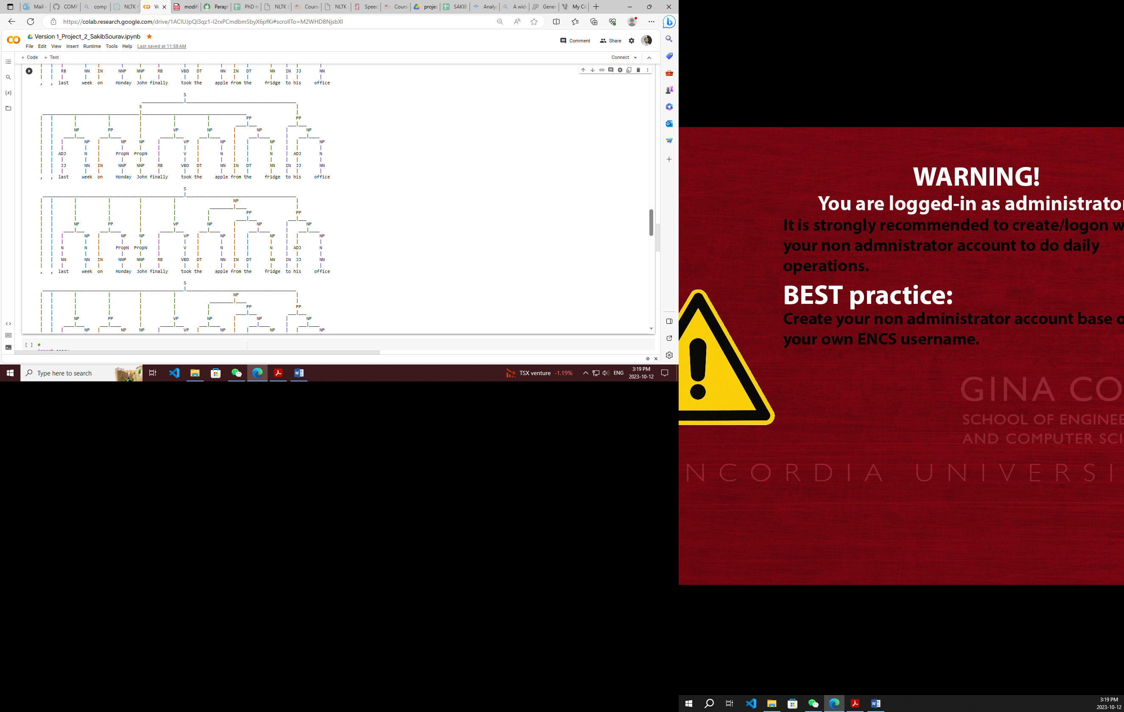

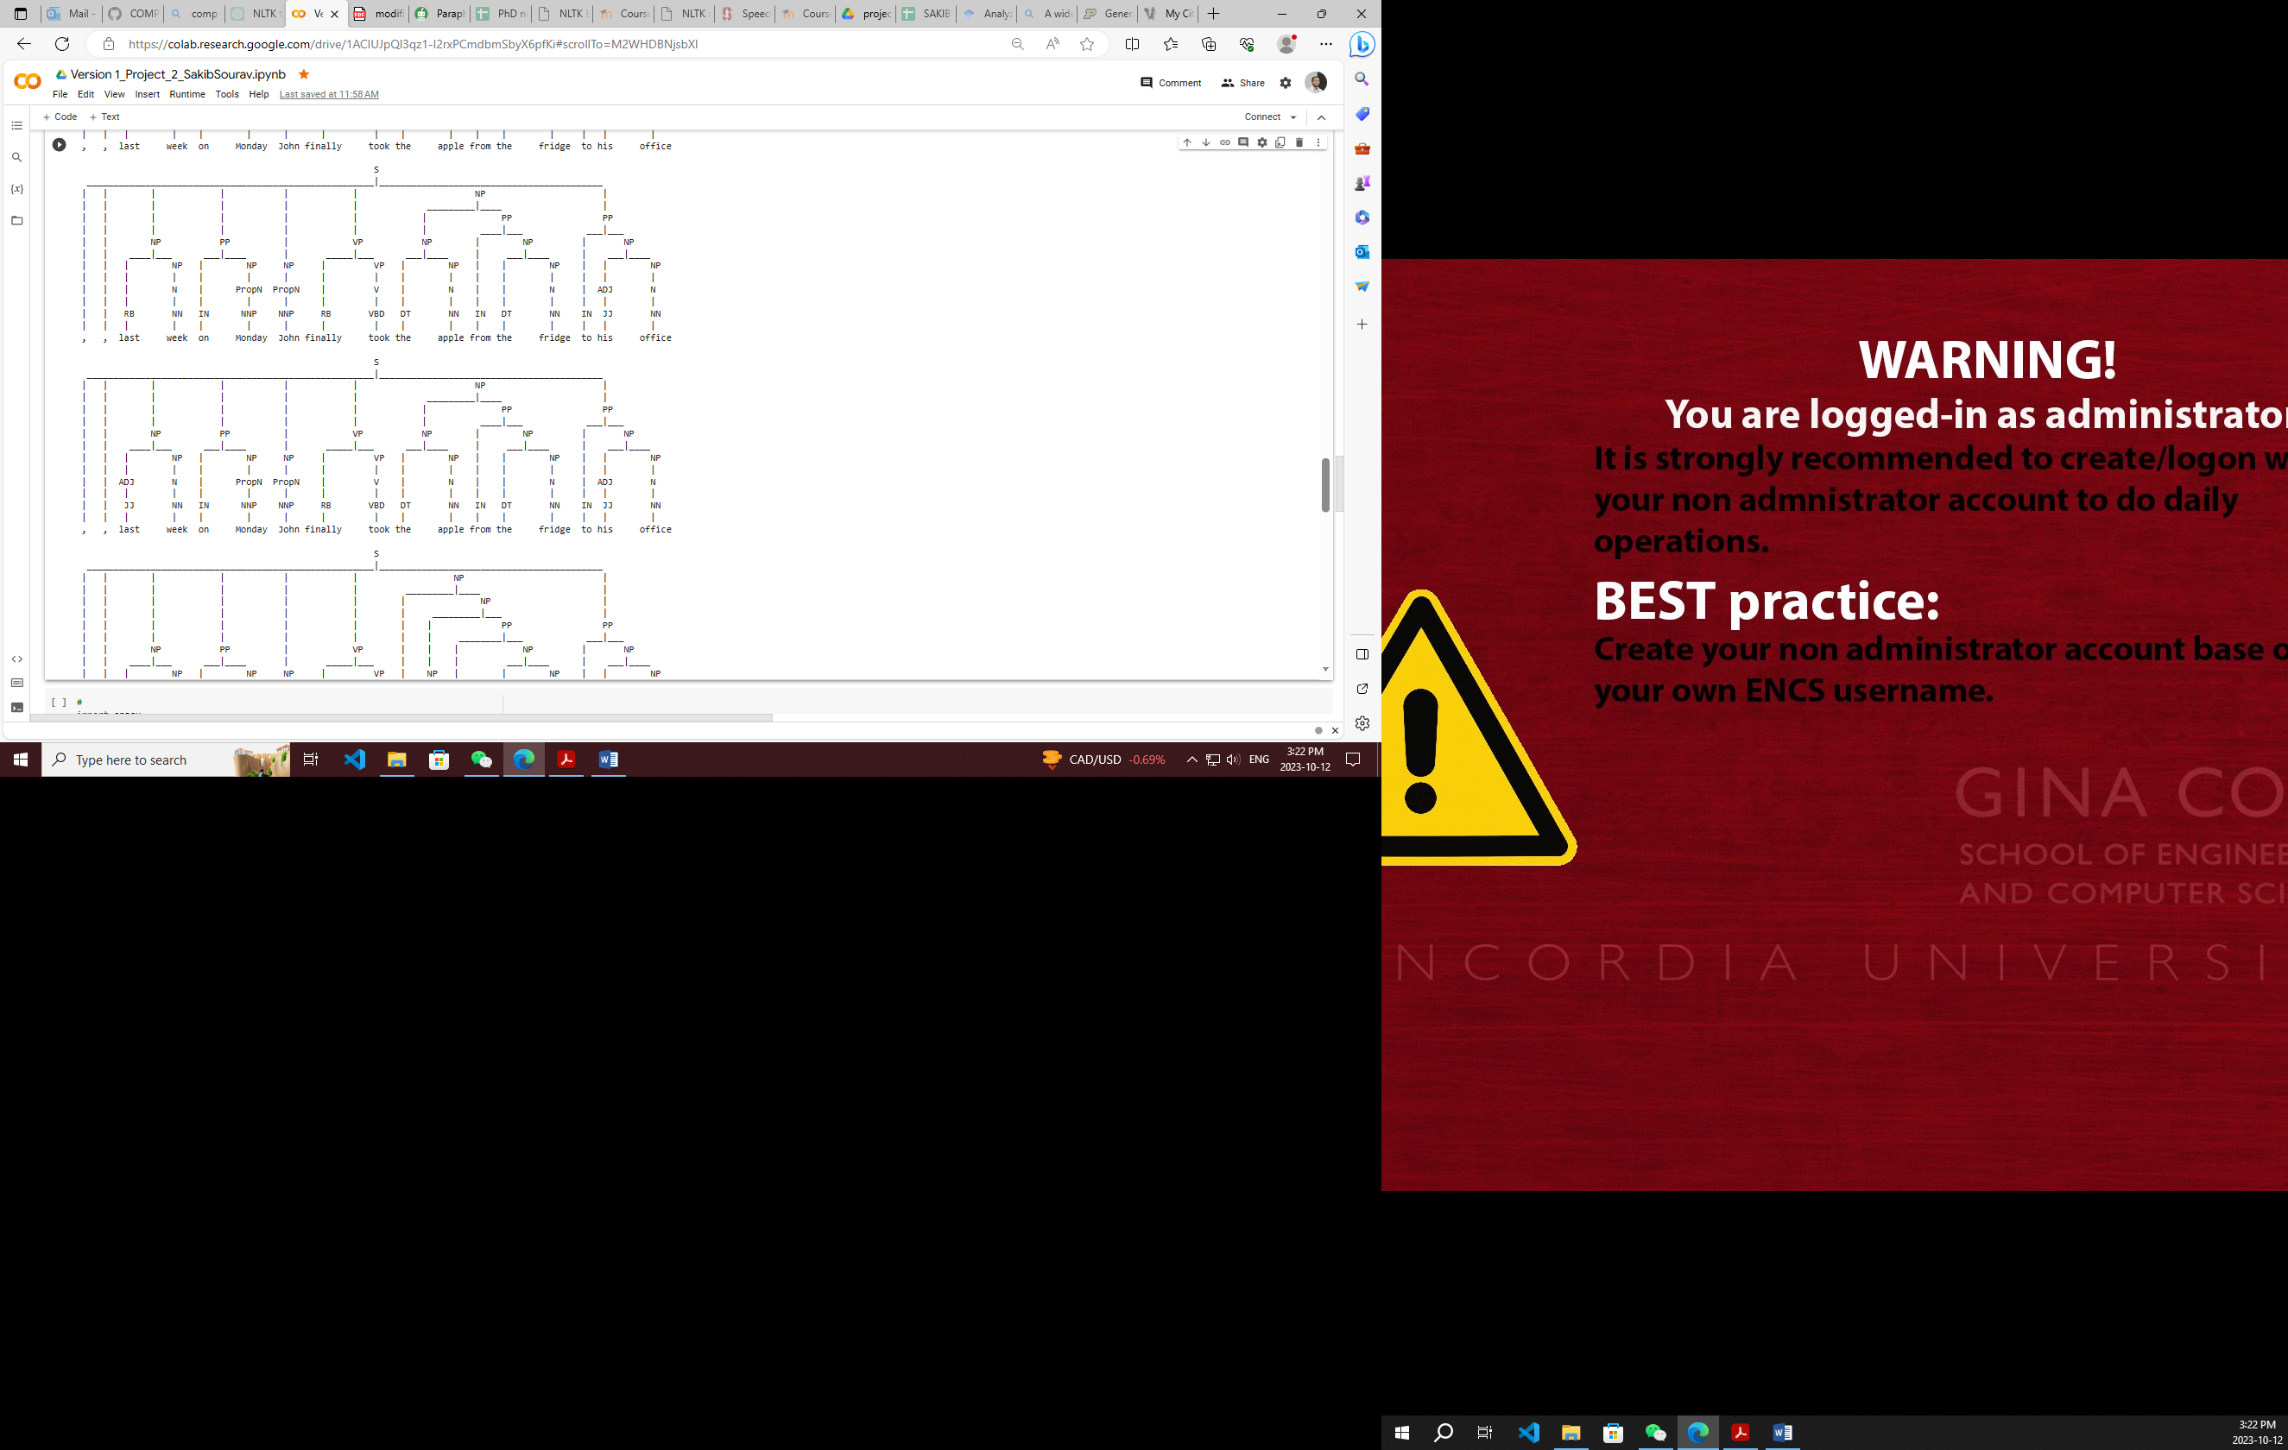

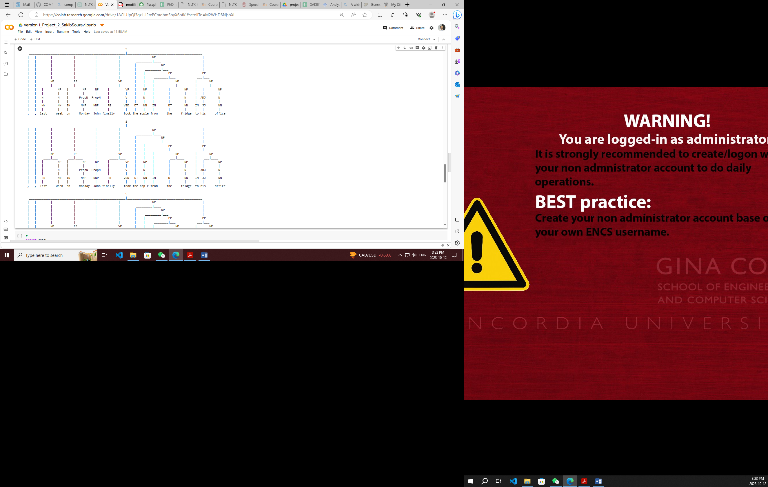

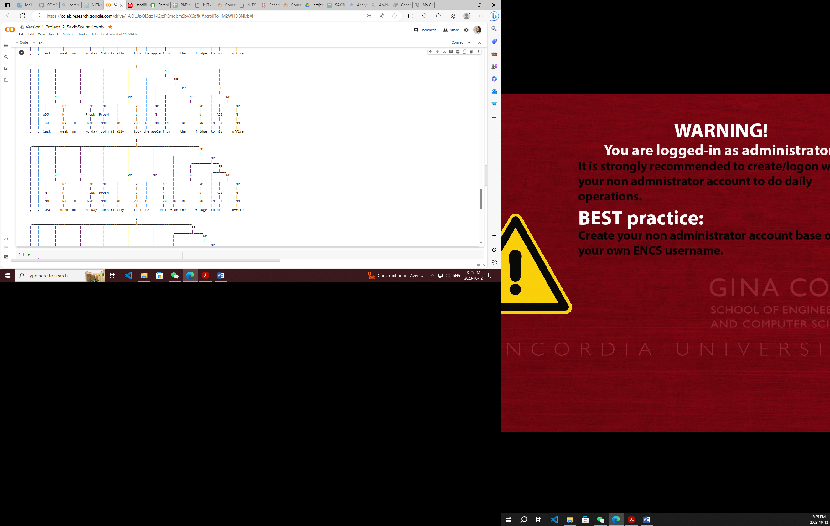

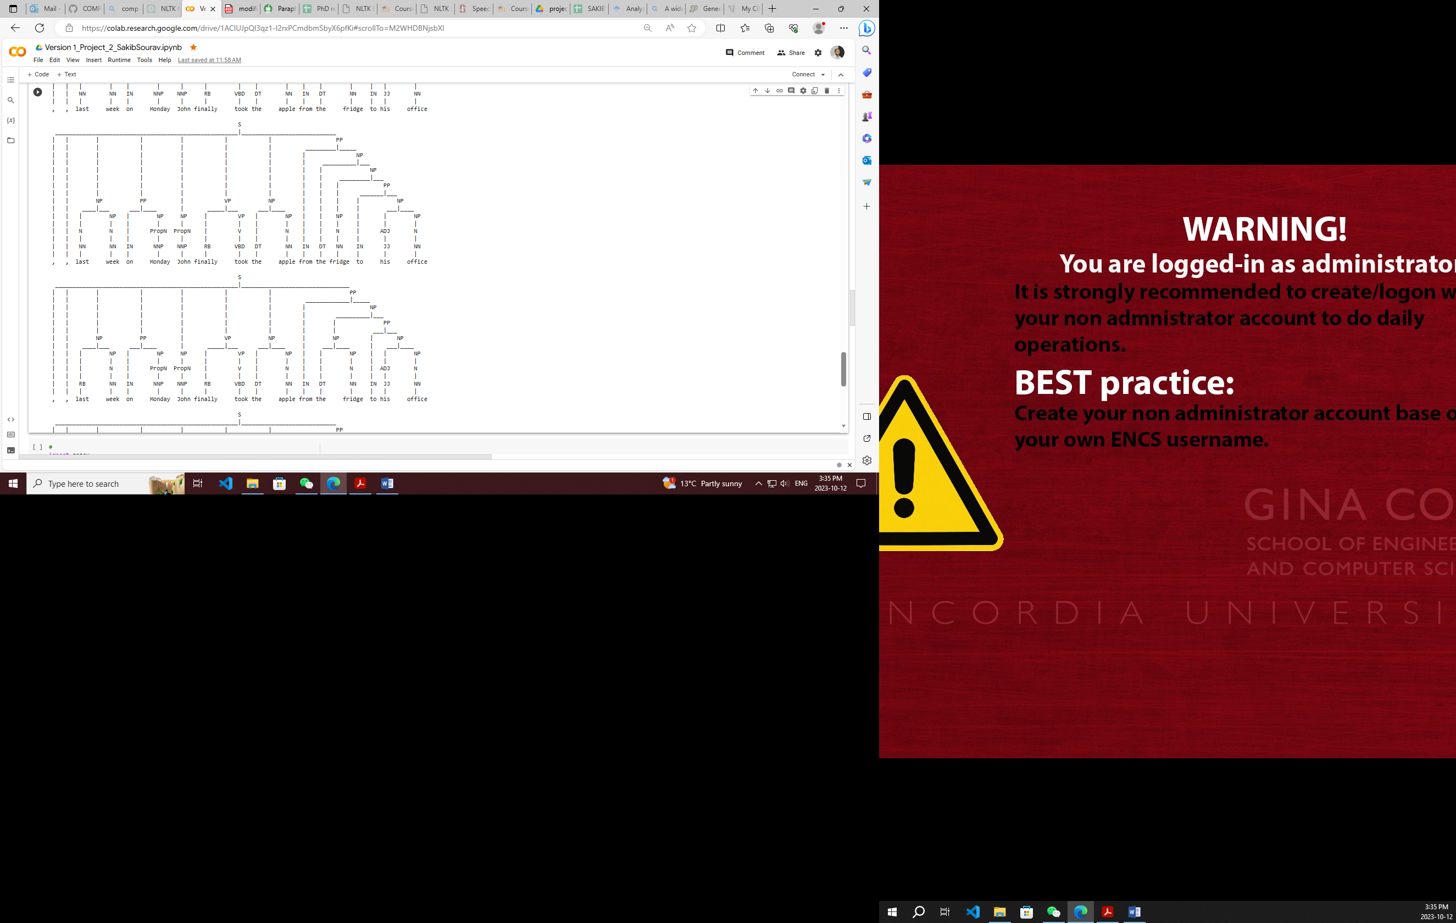

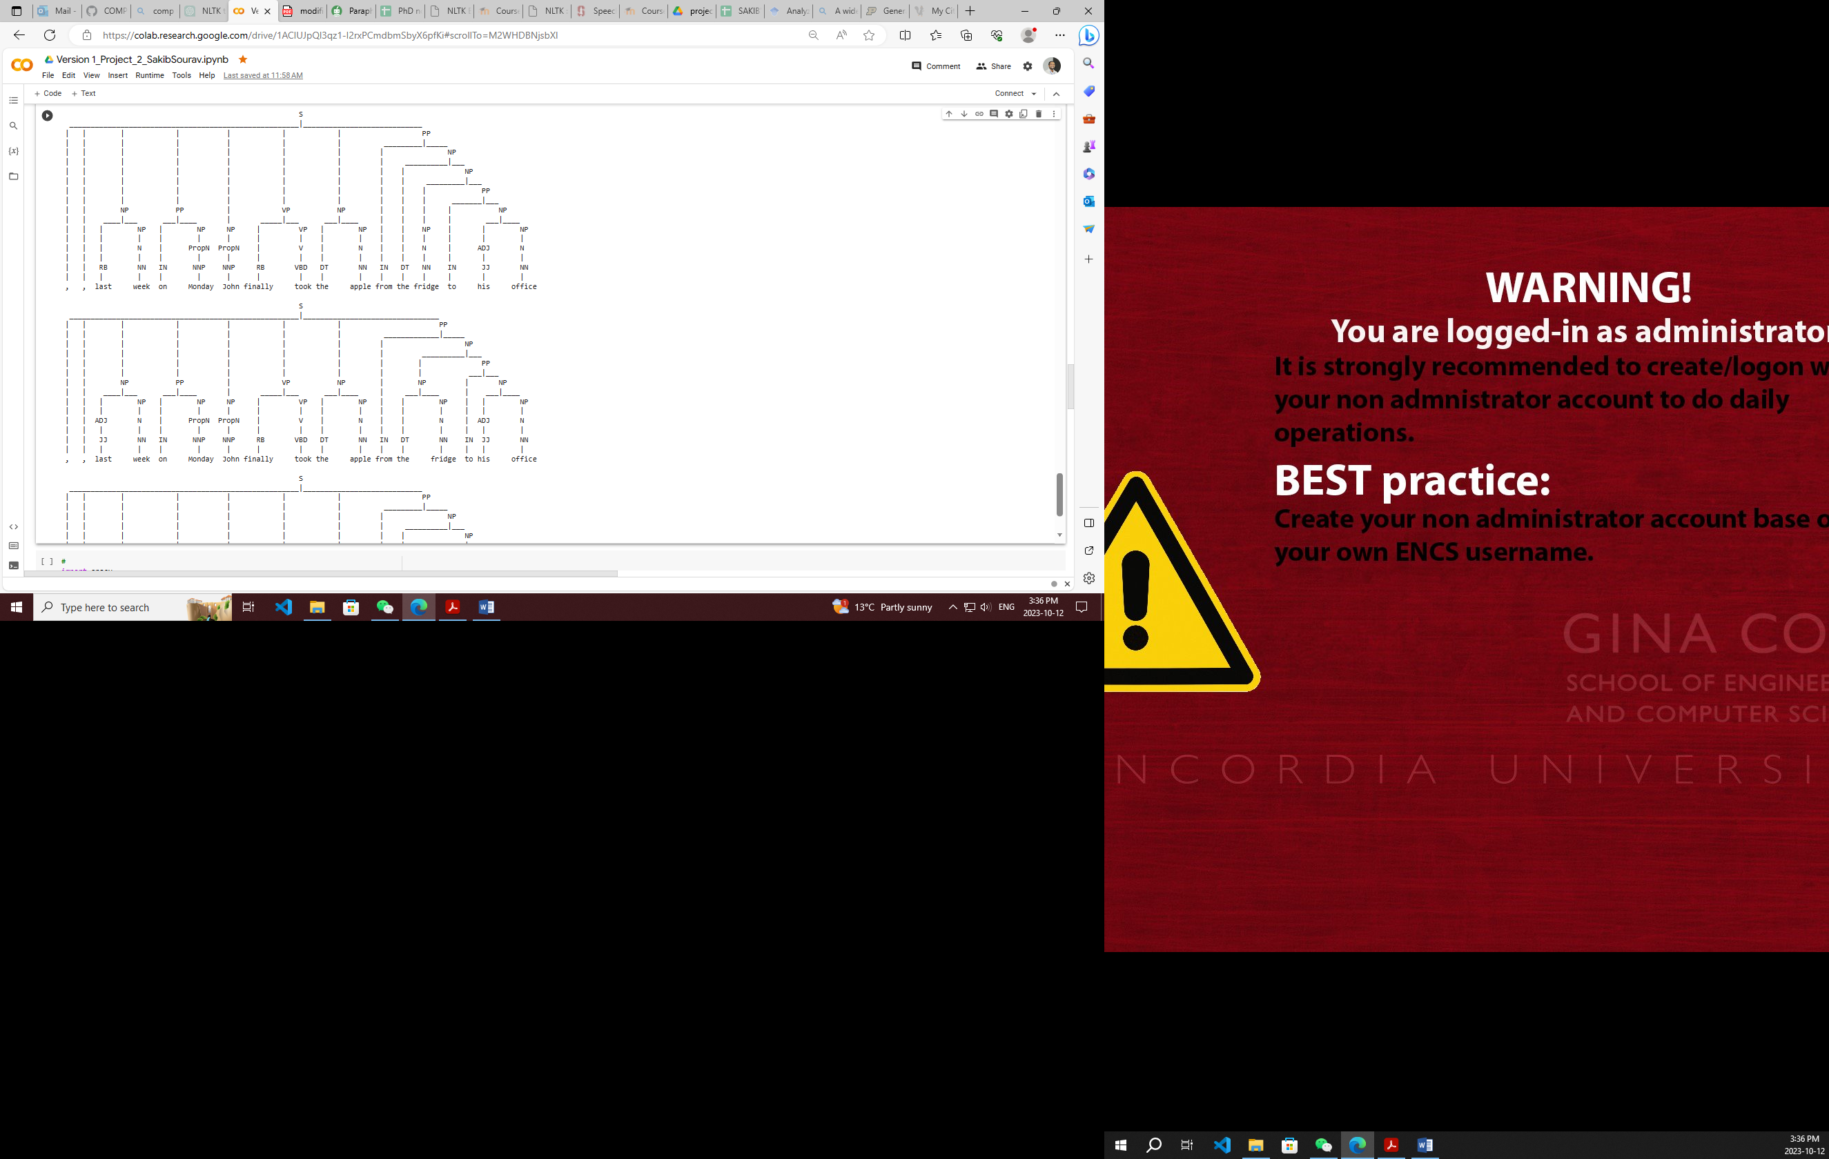

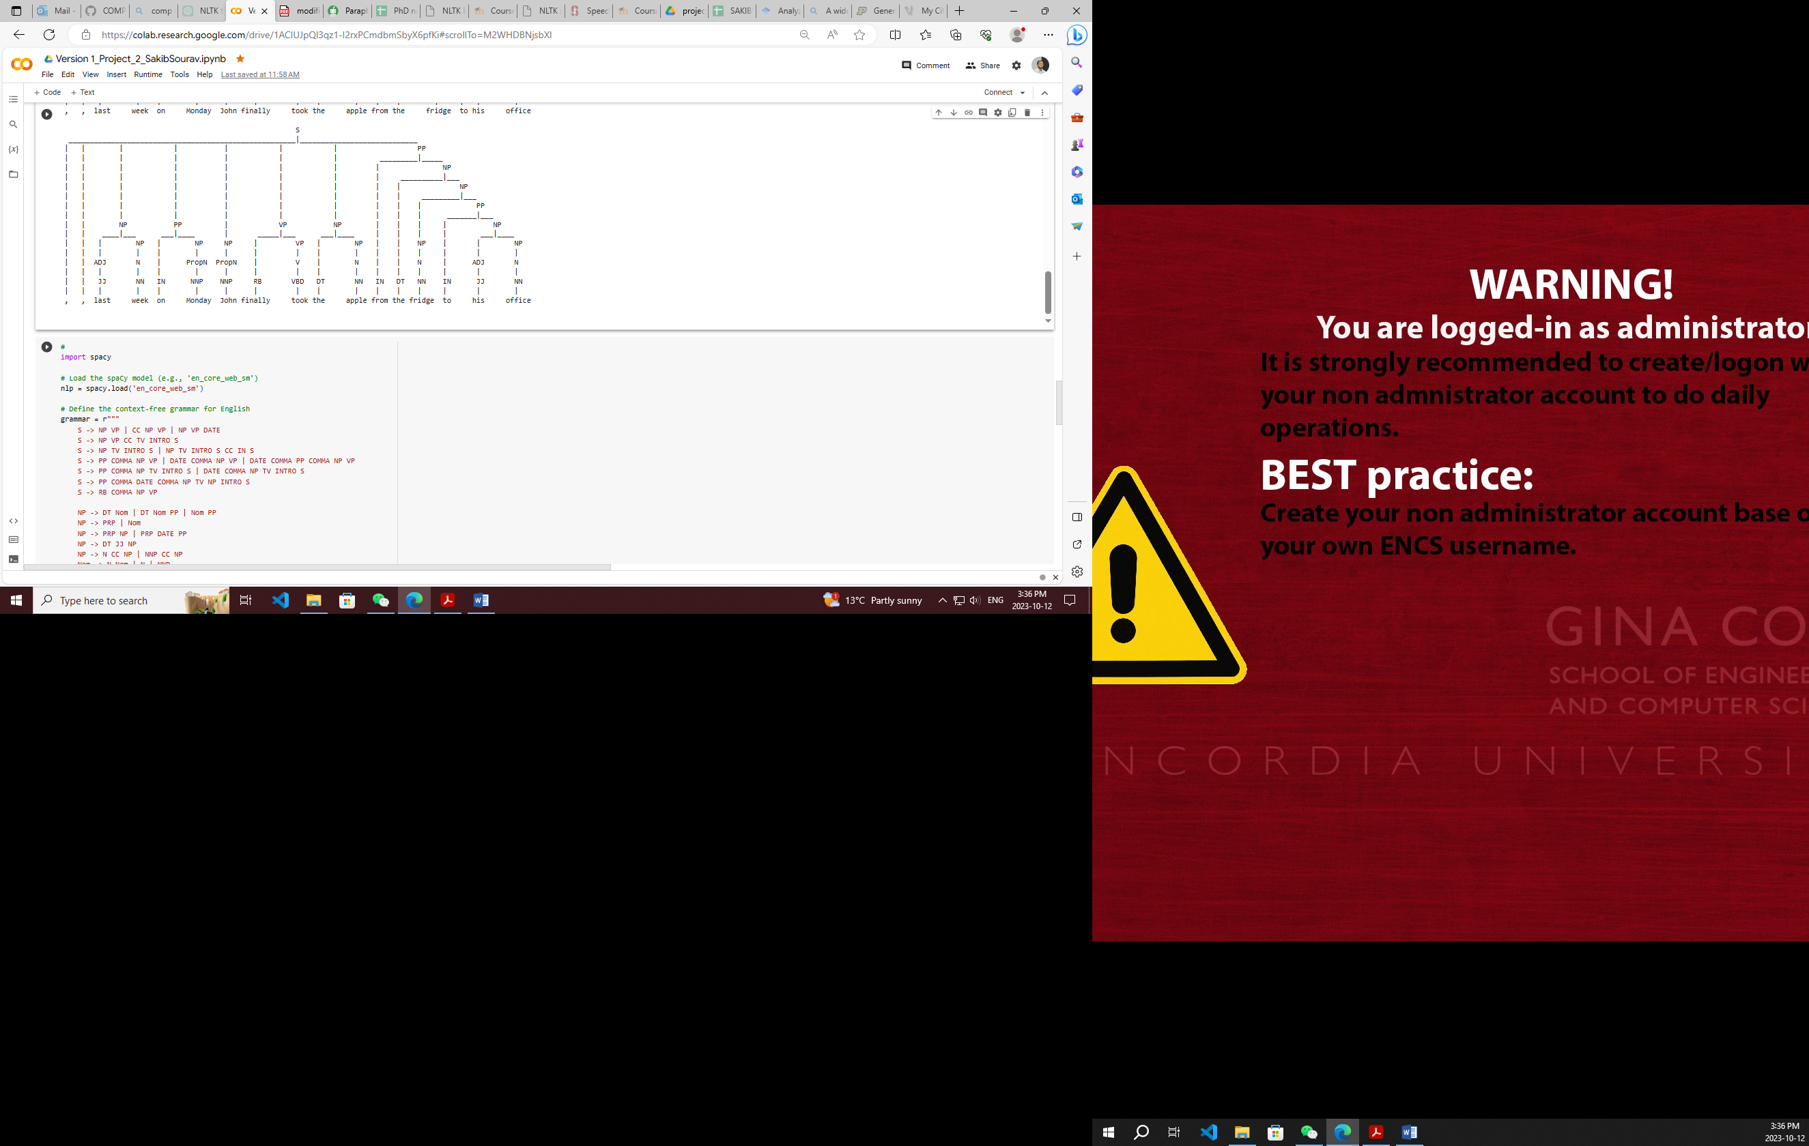

## **1.5 Test Scenario 5**

Input: Heart rate greater than 90 beats/minute

Result: The proofreading results and text preprocess pipeline can be delivered, and the   
 programme can operate correctly. Earley parse process results are displayed below.

Heart rate greater than 90 beats/minute

S

__________|__________

| VP

| __________|___

| | VP

| | ________|___

NP | | NP

____|___ | | ___|_______

| NP | | | NP

| | | | | |

N N V V ADJ N

| | | | | |

NN NN VB VB JJR NN

| | | | | |

heart rate greater than 90 beats/minute

S

__________|__________

| VP

| __________|___

| | VP

| | ________|___

NP | | NP

____|___ | | ___|_______

| NP | | | NP

| | | | | |

N N V V N N

| | | | | |

NN NN VB VB NN NN

| | | | | |

heart rate greater than 90 beats/minute

S

__________|__________

| VP

| __________|___

NP | VP

____|___ | ________|_______

| NP | | | NP

| | | | | |

N N V V ADJ N

| | | | | |

NN NN VB VB JJR NN

| | | | | |

heart rate greater than 90 beats/minute

## **1.6 Test Scenario 6**

Input: Body temperature over 38 or under 36 degrees Celsius.

Result: The proofreading results and text preprocess pipeline can be delivered, and the   
 programme can operate correctly. Earley parse process results are displayed below.

Body temperature over 38 or under 36 degrees Celsius

S

________________|_____________

| | S

| | ___|_____________

S | VP |

_______________|________ | ____|___ |

NP VP | | NP |

____|_______ ____|___ | | ___|_____ |

| NP | NP | | | NP NP

| | | | | | | | |

N N V N | V N N N

| | | | | | | | |

NN NN VB NN CC VB NN NN NN

| | | | | | | | |

body temperature over 38 or under 36 degrees celsius

S

________________|_________________

S | S

_______________|________ | _______|___________

NP VP | VP NP

____|_______ ____|___ | ____|___ _____|_____

| NP | NP | | NP | NP

| | | | | | | | |

N N V N | V N N N

| | | | | | | | |

NN NN VB NN CC VB NN NN NN

| | | | | | | | |

body temperature over 38 or under 36 degrees celsius

S

________________|_____________

| | S

| | ________|_____

S | | NP

_______________|________ | | _________|_____

NP VP | | | NP

____|_______ ____|___ | | | _____|_____

| NP | NP | VP | | NP

| | | | | | | | |

N N V N | V N N N

| | | | | | | | |

NN NN VB NN CC VB NN NN NN

| | | | | | | | |

body temperature over 38 or under 36 degrees celsius

S

________________|_____________

| | S

| | |

| | VP

| | ________|_____

S | | NP

_______________|________ | | _________|_____

NP VP | | | NP

____|_______ ____|___ | | | _____|_____

| NP | NP | | | | NP

| | | | | | | | |

N N V N | V N N N

| | | | | | | | |

NN NN VB NN CC VB NN NN NN

| | | | | | | | |

body temperature over 38 or under 36 degrees Celsius

## **1.7 Test Scenario 7**

Input: Respiratory rate greater than 20 breaths/minute or partial pressure of CO2 less than 32 mmHg

Result: The proofreading results and text preprocess pipeline can be delivered, and the   
 programme can operate correctly. Earley parse process results are displayed below.

S

___________________________________________|__________________________

S | S

__________|__________ | _______|_____________

| VP | NP |

| __________|___ | ____________|_______ |

| | VP | | PP VP

| | ________|___ | | ___|___ ____|___

NP | | NP | NP PP | | NP

_______|___ | | ___|________ | _____|_____ ___|___ | | ___|___

| NP | | | NP | | NP | NP VP | | NP

| | | | | | | | | | | | | | |

N N V V N N | N N | N V V N N

| | | | | | | | | | | | | | |

NN NN VB VB NN NN CC NN NN IN NN VB VB NN NN

| | | | | | | | | | | | | | |

respiratory rate greater than 20 breaths/minute or partial pressure of co2 less than 32 mmhg

S

___________________________________________|______________________

| | S

| | _______|_____________

S | NP |

__________|__________ | ______________|___ |

| VP | | NP |

| __________|___ | | __________|___ |

| | VP | | | PP VP

| | ________|___ | | | ___|___ ____|___

NP | | NP | | | PP | | NP

_______|___ | | ___|________ | | | ___|___ | | ___|___

| NP | | | NP | | NP | NP VP | | NP

| | | | | | | | | | | | | | |

N N V V N N | N N | N V V N N

| | | | | | | | | | | | | | |

NN NN VB VB NN NN CC NN NN IN NN VB VB NN NN

| | | | | | | | | | | | | | |

respiratory rate greater than 20 breaths/minute or partial pressure of co2 less than 32 mmhg

S

___________________________________________|______________________________

S | S

__________|__________ | ___________|_____________

| VP | | VP

| __________|___ | | _________|___

| | VP | NP | VP

| | ________|___ | ____________|_______ | ________|___

NP | | NP | NP PP | | NP

_______|___ | | ___|________ | _____|_____ ___|___ | | ___|___

| NP | | | NP | | NP | NP | | | NP

| | | | | | | | | | | | | | |

N N V V N N | N N | N V V N N

| | | | | | | | | | | | | | |

NN NN VB VB NN NN CC NN NN IN NN VB VB NN NN

| | | | | | | | | | | | | | |

respiratory rate greater than 20 breaths/minute or partial pressure of co2 less than 32 mmhg

S

___________________________________________|__________________________

S | S

__________|__________ | ___________|_____________

| VP | NP VP

| __________|___ | ______________|___ _________|___

| | VP | | NP | VP

| | ________|___ | | __________|___ | ________|___

NP | | NP | | | PP | | NP

_______|___ | | ___|________ | | | ___|___ | | ___|___

| NP | | | NP | | NP | NP | | | NP

| | | | | | | | | | | | | | |

N N V V N N | N N | N V V N N

| | | | | | | | | | | | | | |

NN NN VB VB NN NN CC NN NN IN NN VB VB NN NN

| | | | | | | | | | | | | | |

respiratory rate greater than 20 breaths/minute or partial pressure of co2 less than 32 mmhg

S

___________________________________________|__________________________

S | S

__________|__________ | ____________________|___

| VP | | PP

| __________|___ | | ___|_________

| | VP | S PP VP

| | ________|___ | | ___|___ ____|___

NP | | NP | NP PP | | NP

_______|___ | | ___|________ | _____|_____ ___|___ | | ___|___

| NP | | | NP | | NP | NP VP | | NP

| | | | | | | | | | | | | | |

N N V V N N | N N | N V V N N

| | | | | | | | | | | | | | |

NN NN VB VB NN NN CC NN NN IN NN VB VB NN NN

| | | | | | | | | | | | | | |

respiratory rate greater than 20 breaths/minute or partial pressure of co2 less than 32 mmhg

S

___________________________________________|__________________________

| | S

| | ____________________|___

S | | PP

__________|__________ | | _______|_________

| VP | | | VP

| __________|___ | | | _________|___

| | VP | S | | VP

| | ________|___ | | | | ________|___

NP | | NP | NP PP | | NP

_______|___ | | ___|________ | _____|_____ ___|___ | | ___|___

| NP | | | NP | | NP | NP | | | NP

| | | | | | | | | | | | | | |

N N V V N N | N N | N V V N N

| | | | | | | | | | | | | | |

NN NN VB VB NN NN CC NN NN IN NN VB VB NN NN

| | | | | | | | | | | | | | |

respiratory rate greater than 20 breaths/minute or partial pressure of co2 less than 32 mmhg

S

___________________________________________|__________________________

| | S

| | |

S | NP

__________|__________ | ____________________|___

| VP | | PP

| __________|___ | | ___|_________

| | VP | | PP VP

| | ________|___ | | ___|___ ____|___

NP | | NP | NP PP | | NP

_______|___ | | ___|________ | _____|_____ ___|___ | | ___|___

| NP | | | NP | | NP | NP VP | | NP

| | | | | | | | | | | | | | |

N N V V N N | N N | N V V N N

| | | | | | | | | | | | | | |

NN NN VB VB NN NN CC NN NN IN NN VB VB NN NN

| | | | | | | | | | | | | | |

respiratory rate greater than 20 breaths/minute or partial pressure of co2 less than 32 mmhg

S

___________________________________________|__________________________

| | S

| | |

| | NP

| | ____________________|___

S | | PP

__________|__________ | | _______|_________

| VP | | | VP

| __________|___ | | | _________|___

| | VP | | | | VP

| | ________|___ | | | | ________|___

NP | | NP | NP PP | | NP

_______|___ | | ___|________ | _____|_____ ___|___ | | ___|___

| NP | | | NP | | NP | NP | | | NP

| | | | | | | | | | | | | | |

N N V V N N | N N | N V V N N

| | | | | | | | | | | | | | |

NN NN VB VB NN NN CC NN NN IN NN VB VB NN NN

| | | | | | | | | | | | | | |

respiratory rate greater than 20 breaths/minute or partial pressure of co2 less than 32 mmhg

S

___________________________________________|_______

| | S

| | |

| | NP

| | _______|______

S | | NP

__________|__________ | | ______|___________

| VP | | | PP

| __________|___ | | | ___|_________

| | VP | | | PP VP

| | ________|___ | | | ___|___ ____|___

NP | | NP | | | PP | | NP

_______|___ | | ___|________ | | | ___|___ | | ___|___

| NP | | | NP | | NP | NP VP | | NP

| | | | | | | | | | | | | | |

N N V V N N | N N | N V V N N

| | | | | | | | | | | | | | |

NN NN VB VB NN NN CC NN NN IN NN VB VB NN NN

| | | | | | | | | | | | | | |

respiratory rate greater than 20 breaths/minute or partial pressure of co2 less than 32 mmhg

S

___________________________________________|_______

| | S

| | |

| | NP

| | _______|______

| | | NP

| | | ______|___________

S | | | PP

__________|__________ | | | _______|_________

| VP | | | | VP

| __________|___ | | | | _________|___

| | VP | | | | | VP

| | ________|___ | | | | | ________|___

NP | | NP | | | PP | | NP

_______|___ | | ___|________ | | | ___|___ | | ___|___

| NP | | | NP | | NP | NP | | | NP

| | | | | | | | | | | | | | |

N N V V N N | N N | N V V N N

| | | | | | | | | | | | | | |

NN NN VB VB NN NN CC NN NN IN NN VB VB NN NN

| | | | | | | | | | | | | | |

respiratory rate greater than 20 breaths/minute or partial pressure of co2 less than 32 mmhg

S

____________________________|______________________________

S |

______________|__________________________________ |

S | | |

__________|__________ | | |

| VP | | PP

| __________|___ | | ___|_________

| | VP | S PP VP

| | ________|___ | | ___|___ ____|___

NP | | NP | NP PP | | NP

_______|___ | | ___|________ | _____|_____ ___|___ | | ___|___

| NP | | | NP | | NP | NP VP | | NP

| | | | | | | | | | | | | | |

N N V V N N | N N | N V V N N

| | | | | | | | | | | | | | |

NN NN VB VB NN NN CC NN NN IN NN VB VB NN NN

| | | | | | | | | | | | | | |

respiratory rate greater than 20 breaths/minute or partial pressure of co2 less than 32 mmhg

S

____________________________|______________________________

S |

______________|__________________________________ |

S | | PP

__________|__________ | | _______|_________

| VP | | | VP

| __________|___ | | | _________|___

| | VP | S | | VP

| | ________|___ | | | | ________|___

NP | | NP | NP PP | | NP

_______|___ | | ___|________ | _____|_____ ___|___ | | ___|___

| NP | | | NP | | NP | NP | | | NP

| | | | | | | | | | | | | | |

N N V V N N | N N | N V V N N

| | | | | | | | | | | | | | |

NN NN VB VB NN NN CC NN NN IN NN VB VB NN NN

| | | | | | | | | | | | | | |

respiratory rate greater than 20 breaths/minute or partial pressure of co2 less than 32 mmhg

S

______________________________________________|______________________________

S |

___|____________ |

| VP |

| _____|_____________ |

| | VP |

| | _____________|_________ |

| | | NP |

| | | __________________|___ |

| | | | NP PP

| | | | _____________|_____ ___|_________

| | | | | NP PP VP

| | | | | _________|_____ ___|___ ____|___

NP | | | | | NP PP | | NP

_______|___ | | | | | _____|_____ ___|___ | | ___|___

| NP | | | | | | NP | NP VP | | NP

| | | | | | | | | | | | | | |

N N V V N N | N N | N V V N N

| | | | | | | | | | | | | | |

NN NN VB VB NN NN CC NN NN IN NN VB VB NN NN

| | | | | | | | | | | | | | |

respiratory rate greater than 20 breaths/minute or partial pressure of co2 less than 32 mmhg

S

______________________________________________|______________________________

S |

___|____________ |

| VP |

| _____|_____________ |

| | VP |

| | _____________|_________ |

| | | NP PP

| | | __________________|___ _______|_________

| | | | NP | VP

| | | | _____________|_____ | _________|___

| | | | | NP | | VP

| | | | | _________|_____ | | ________|___

NP | | | | | NP PP | | NP

_______|___ | | | | | _____|_____ ___|___ | | ___|___

| NP | | | | | | NP | NP | | | NP

| | | | | | | | | | | | | | |

N N V V N N | N N | N V V N N

| | | | | | | | | | | | | | |

NN NN VB VB NN NN CC NN NN IN NN VB VB NN NN

| | | | | | | | | | | | | | |

respiratory rate greater than 20 breaths/minute or partial pressure of co2 less than 32 mmhg

S

__________________________________________________|___________

| VP

| _____________________________________________|__________________

| VP |

| _____|_____________ |

| | VP |

| | _____________|_________ |

| | | NP |

| | | __________________|___ |

| | | | NP PP

| | | | _____________|_____ ___|_________

| | | | | NP PP VP

| | | | | _________|_____ ___|___ ____|___

NP | | | | | NP PP | | NP

_______|___ | | | | | _____|_____ ___|___ | | ___|___

| NP | | | | | | NP | NP VP | | NP

| | | | | | | | | | | | | | |

N N V V N N | N N | N V V N N

| | | | | | | | | | | | | | |

NN NN VB VB NN NN CC NN NN IN NN VB VB NN NN

| | | | | | | | | | | | | | |

respiratory rate greater than 20 breaths/minute or partial pressure of co2 less than 32 mmhg

S

__________________________________________________|___________

| VP

| _____________________________________________|__________________

| VP |

| _____|_____________ |

| | VP |

| | _____________|_________ |

| | | NP PP

| | | __________________|___ _______|_________

| | | | NP | VP

| | | | _____________|_____ | _________|___

| | | | | NP | | VP

| | | | | _________|_____ | | ________|___

NP | | | | | NP PP | | NP

_______|___ | | | | | _____|_____ ___|___ | | ___|___

| NP | | | | | | NP | NP | | | NP

| | | | | | | | | | | | | | |

N N V V N N | N N | N V V N N

| | | | | | | | | | | | | | |

NN NN VB VB NN NN CC NN NN IN NN VB VB NN NN

| | | | | | | | | | | | | | |

respiratory rate greater than 20 breaths/minute or partial pressure of co2 less than 32 mmhg

S

__________|___________________

| VP

| ___________________|_______________________________

| | VP

| | _______________________________|__________________

| | VP |

| | _____________|_________ |

| | | NP |

| | | __________________|___ |

| | | | NP PP

| | | | _____________|_____ ___|_________

| | | | | NP PP VP

| | | | | _________|_____ ___|___ ____|___

NP | | | | | NP PP | | NP

_______|___ | | | | | _____|_____ ___|___ | | ___|___

| NP | | | | | | NP | NP VP | | NP

| | | | | | | | | | | | | | |

N N V V N N | N N | N V V N N

| | | | | | | | | | | | | | |

NN NN VB VB NN NN CC NN NN IN NN VB VB NN NN

| | | | | | | | | | | | | | |

respiratory rate greater than 20 breaths/minute or partial pressure of co2 less than 32 mmhg

S

__________|___________________

| VP

| ___________________|_______________________________

| | VP

| | _______________________________|__________________

| | VP |

| | _____________|_________ |

| | | NP PP

| | | __________________|___ _______|_________

| | | | NP | VP

| | | | _____________|_____ | _________|___

| | | | | NP | | VP

| | | | | _________|_____ | | ________|___

NP | | | | | NP PP | | NP

_______|___ | | | | | _____|_____ ___|___ | | ___|___

| NP | | | | | | NP | NP | | | NP

| | | | | | | | | | | | | | |

N N V V N N | N N | N V V N N

| | | | | | | | | | | | | | |

NN NN VB VB NN NN CC NN NN IN NN VB VB NN NN

| | | | | | | | | | | | | | |

respiratory rate greater than 20 breaths/minute or partial pressure of co2 less than 32 mmhg

S

__________|___________________

| VP

| ___________________|_______________________________

| | VP

| | _____________________________________________|______

| | | NP

| | | ____________________________|___________

| | | NP |

| | | __________________|___ |

| | | | NP PP

| | | | _____________|_____ ___|_________

| | | | | NP PP VP

| | | | | _________|_____ ___|___ ____|___

NP | | | | | NP PP | | NP

_______|___ | | | | | _____|_____ ___|___ | | ___|___

| NP | | | | | | NP | NP VP | | NP

| | | | | | | | | | | | | | |

N N V V N N | N N | N V V N N

| | | | | | | | | | | | | | |

NN NN VB VB NN NN CC NN NN IN NN VB VB NN NN

| | | | | | | | | | | | | | |

respiratory rate greater than 20 breaths/minute or partial pressure of co2 less than 32 mmhg

S

__________|___________________

| VP

| ___________________|_______________________________

| | VP

| | _____________________________________________|______

| | | NP

| | | ____________________________|___________

| | | NP PP

| | | __________________|___ _______|_________

| | | | NP | VP

| | | | _____________|_____ | _________|___

| | | | | NP | | VP

| | | | | _________|_____ | | ________|___

NP | | | | | NP PP | | NP

_______|___ | | | | | _____|_____ ___|___ | | ___|___

| NP | | | | | | NP | NP | | | NP

| | | | | | | | | | | | | | |

N N V V N N | N N | N V V N N

| | | | | | | | | | | | | | |

NN NN VB VB NN NN CC NN NN IN NN VB VB NN NN

| | | | | | | | | | | | | | |

respiratory rate greater than 20 breaths/minute or partial pressure of co2 less than 32 mmhg

S

___|____________

| VP

| _____|____

| | VP

| | ____|__________________

| | | NP

| | | __________________|____________________________

| | | | NP

| | | | ________________________|___________

| | | | NP PP

| | | | _____________|_____ ___|_________

| | | | | NP PP VP

| | | | | _________|_____ ___|___ ____|___

NP | | | | | NP PP | | NP

_______|___ | | | | | _____|_____ ___|___ | | ___|___

| NP | | | | | | NP | NP VP | | NP

| | | | | | | | | | | | | | |

N N V V N N | N N | N V V N N

| | | | | | | | | | | | | | |

NN NN VB VB NN NN CC NN NN IN NN VB VB NN NN

| | | | | | | | | | | | | | |

respiratory rate greater than 20 breaths/minute or partial pressure of co2 less than 32 mmhg

S

___|____________

| VP

| _____|____

| | VP

| | ____|__________________

| | | NP

| | | __________________|____________________________

| | | | NP

| | | | ________________________|___________

| | | | | PP

| | | | | _______|_________

| | | | NP | VP

| | | | _____________|_____ | _________|___

| | | | | NP | | VP

| | | | | _________|_____ | | ________|___

NP | | | | | NP PP | | NP

_______|___ | | | | | _____|_____ ___|___ | | ___|___

| NP | | | | | | NP | NP | | | NP

| | | | | | | | | | | | | | |

N N V V N N | N N | N V V N N

| | | | | | | | | | | | | | |

NN NN VB VB NN NN CC NN NN IN NN VB VB NN NN

| | | | | | | | | | | | | | |

respiratory rate greater than 20 breaths/minute or partial pressure of co2 less than 32 mmhg

S

___|____________

| VP

| _____|____

| | VP

| | ____|__________________

| | | NP

| | | __________________|________________________

| | | | NP

| | | | __________________________________|_______

| | | | | NP

| | | | | __________________________|___

| | | | | | PP

| | | | | | ___|_________

| | | | | NP PP VP

| | | | | _____|_____ ___|___ ____|___

NP | | | | | NP PP | | NP

_______|___ | | | | | _____|_____ ___|___ | | ___|___

| NP | | | | | | NP | NP VP | | NP

| | | | | | | | | | | | | | |

N N V V N N | N N | N V V N N

| | | | | | | | | | | | | | |

NN NN VB VB NN NN CC NN NN IN NN VB VB NN NN

| | | | | | | | | | | | | | |

respiratory rate greater than 20 breaths/minute or partial pressure of co2 less than 32 mmhg

S

___|____________

| VP

| _____|____

| | VP

| | ____|__________________

| | | NP

| | | __________________|________________________

| | | | NP

| | | | __________________________________|_______

| | | | | NP

| | | | | __________________________|___

| | | | | | PP

| | | | | | _______|_________

| | | | | | | VP

| | | | | | | _________|___

| | | | | NP | | VP

| | | | | _____|_____ | | ________|___

NP | | | | | NP PP | | NP

_______|___ | | | | | _____|_____ ___|___ | | ___|___

| NP | | | | | | NP | NP | | | NP

| | | | | | | | | | | | | | |

N N V V N N | N N | N V V N N

| | | | | | | | | | | | | | |

NN NN VB VB NN NN CC NN NN IN NN VB VB NN NN

| | | | | | | | | | | | | | |

respiratory rate greater than 20 breaths/minute or partial pressure of co2 less than 32 mmhg

S

___|____________

| VP

| _____|____

| | VP

| | ____|________

| | | NP

| | | ________|_________

| | | | NP

| | | | _________|_________________

| | | | | NP

| | | | | _________________|______________

| | | | | | NP

| | | | | | ____________________|___

| | | | | | | PP

| | | | | | | ___|_________

| | | | | | | PP VP

| | | | | | | ___|___ ____|___

NP | | | | | NP PP | | NP

_______|___ | | | | | _____|_____ ___|___ | | ___|___

| NP | | | | | | NP | NP VP | | NP

| | | | | | | | | | | | | | |

N N V V N N | N N | N V V N N

| | | | | | | | | | | | | | |

NN NN VB VB NN NN CC NN NN IN NN VB VB NN NN

| | | | | | | | | | | | | | |

respiratory rate greater than 20 breaths/minute or partial pressure of co2 less than 32 mmhg

S

___|____________

| VP

| _____|____

| | VP

| | ____|________

| | | NP

| | | ________|_________

| | | | NP

| | | | _________|_________________

| | | | | NP

| | | | | _________________|______________

| | | | | | NP

| | | | | | ____________________|___

| | | | | | | PP

| | | | | | | _______|_________

| | | | | | | | VP

| | | | | | | | _________|___

| | | | | | | | | VP

| | | | | | | | | ________|___

NP | | | | | NP PP | | NP

_______|___ | | | | | _____|_____ ___|___ | | ___|___

| NP | | | | | | NP | NP | | | NP

| | | | | | | | | | | | | | |

N N V V N N | N N | N V V N N

| | | | | | | | | | | | | | |

NN NN VB VB NN NN CC NN NN IN NN VB VB NN NN

| | | | | | | | | | | | | | |

respiratory rate greater than 20 breaths/minute or partial pressure of co2 less than 32 mmhg

S

___|____________

| VP

| _____|____

| | VP

| | ____|________

| | | NP

| | | ________|_________

| | | | NP

| | | | _________|_____

| | | | | NP

| | | | | _____|_______

| | | | | | NP

| | | | | | _______|______

| | | | | | | NP

| | | | | | | ______|___________

| | | | | | | | PP

| | | | | | | | ___|_________

| | | | | | | | PP VP

| | | | | | | | ___|___ ____|___

NP | | | | | | | PP | | NP

_______|___ | | | | | | | ___|___ | | ___|___

| NP | | | | | | NP | NP VP | | NP

| | | | | | | | | | | | | | |

N N V V N N | N N | N V V N N

| | | | | | | | | | | | | | |

NN NN VB VB NN NN CC NN NN IN NN VB VB NN NN

| | | | | | | | | | | | | | |

respiratory rate greater than 20 breaths/minute or partial pressure of co2 less than 32 mmhg

S

___|____________

| VP

| _____|____

| | VP

| | ____|________

| | | NP

| | | ________|_________

| | | | NP

| | | | _________|_____

| | | | | NP

| | | | | _____|_______

| | | | | | NP

| | | | | | _______|______

| | | | | | | NP

| | | | | | | ______|___________

| | | | | | | | PP

| | | | | | | | _______|_________

| | | | | | | | | VP

| | | | | | | | | _________|___

| | | | | | | | | | VP

| | | | | | | | | | ________|___

NP | | | | | | | PP | | NP

_______|___ | | | | | | | ___|___ | | ___|___

| NP | | | | | | NP | NP | | | NP

| | | | | | | | | | | | | | |

N N V V N N | N N | N V V N N

| | | | | | | | | | | | | | |

NN NN VB VB NN NN CC NN NN IN NN VB VB NN NN

| | | | | | | | | | | | | | |

respiratory rate greater than 20 breaths/minute or partial pressure of co2 less than 32 mmhg

S

__________|___________________

| VP

| ___________________|_______________________________

| | VP

| | _____________________________________________|__________________

| | | NP |

| | | __________________|___ |

| | | | NP PP

| | | | _____________|_____ ___|_________

| | | | | NP PP VP

| | | | | _________|_____ ___|___ ____|___

NP | | | | | NP PP | | NP

_______|___ | | | | | _____|_____ ___|___ | | ___|___

| NP | | | | | | NP | NP VP | | NP

| | | | | | | | | | | | | | |

N N V V N N | N N | N V V N N

| | | | | | | | | | | | | | |

NN NN VB VB NN NN CC NN NN IN NN VB VB NN NN

| | | | | | | | | | | | | | |

respiratory rate greater than 20 breaths/minute or partial pressure of co2 less than 32 mmhg

S

__________|___________________

| VP

| ___________________|_______________________________

| | VP

| | _____________________________________________|__________________

| | | NP PP

| | | __________________|___ _______|_________

| | | | NP | VP

| | | | _____________|_____ | _________|___

| | | | | NP | | VP

| | | | | _________|_____ | | ________|___

NP | | | | | NP PP | | NP

_______|___ | | | | | _____|_____ ___|___ | | ___|___

| NP | | | | | | NP | NP | | | NP

| | | | | | | | | | | | | | |

N N V V N N | N N | N V V N N

| | | | | | | | | | | | | | |

NN NN VB VB NN NN CC NN NN IN NN VB VB NN NN

| | | | | | | | | | | | | | |

respiratory rate greater than 20 breaths/minute or partial pressure of co2 less than 32 mmhg

# **Outputs in CoNLL Format**

For getting the output of CFG in CoNLL format, I wrote the below code,

# Parse and annotate sentences

for sentence in sentences:

    # Process the sentence with spaCy

    doc = nlp(sentence)

    # Extract POS and NE information and annotate with Ent and MeasEnt

    token_index = 1

    for token in doc:

        word = token.text

        pos = token.pos_

        ne = token.ent_type_  # Named Entity (NE) label

        ent = "Ent"  # Entity Type (customize based on your data)

        meas_ent = "MeasEnt"  # Measured Entity (customize based on your data)

        # Format and print each token's information in CoNLL format

        print(f"{token_index}\t{word}\t_\t{pos}\t{ne}\t{ent}\t{meas_ent}")

        token_index += 1

    # Print an empty line to separate sentences

    print()

The corresponding output in CoNLL format that I get are given below,

John ate the apple at the table.

1 John _ PROPN PERSON Ent MeasEnt

2 ate _ VERB Ent MeasEnt

3 the _ DET Ent MeasEnt

4 apple _ NOUN Ent MeasEnt

5 at _ ADP Ent MeasEnt

6 the _ DET Ent MeasEnt

7 table _ NOUN Ent MeasEnt

8 . _ PUNCT Ent MeasEnt

John, who ate the apple from the fridge, was sick Wednesday.

1 John _ PROPN PERSON Ent MeasEnt

2 , _ PUNCT Ent MeasEnt

3 who _ PRON Ent MeasEnt

4 ate _ VERB Ent MeasEnt

5 the _ DET Ent MeasEnt

6 apple _ NOUN Ent MeasEnt

7 from _ ADP Ent MeasEnt

8 the _ DET Ent MeasEnt

9 fridge _ NOUN Ent MeasEnt

10 , _ PUNCT Ent MeasEnt

11 was _ AUX Ent MeasEnt

12 sick _ ADJ Ent MeasEnt

13 Wednesday _ PROPN DATE Ent MeasEnt

14 . _ PUNCT Ent MeasEnt

On Monday, John ate the apple in his office.

1 On _ ADP Ent MeasEnt

2 Monday _ PROPN DATE Ent MeasEnt

3 , _ PUNCT Ent MeasEnt

4 John _ PROPN PERSON Ent MeasEnt

5 ate _ VERB Ent MeasEnt

6 the _ DET Ent MeasEnt

7 apple _ NOUN Ent MeasEnt

8 in _ ADP Ent MeasEnt

9 his _ PRON Ent MeasEnt

10 office _ NOUN Ent MeasEnt

11 . _ PUNCT Ent MeasEnt

Last week, on Monday, John finally took the apple from the fridge to his office.

1 Last _ ADJ DATE Ent MeasEnt

2 week _ NOUN DATE Ent MeasEnt

3 , _ PUNCT Ent MeasEnt

4 on _ ADP Ent MeasEnt

5 Monday _ PROPN DATE Ent MeasEnt

6 , _ PUNCT Ent MeasEnt

7 John _ PROPN PERSON Ent MeasEnt

8 finally _ ADV Ent MeasEnt

9 took _ VERB Ent MeasEnt

10 the _ DET Ent MeasEnt

11 apple _ NOUN Ent MeasEnt

12 from _ ADP Ent MeasEnt

13 the _ DET Ent MeasEnt

14 fridge _ NOUN Ent MeasEnt

15 to _ ADP Ent MeasEnt

16 his _ PRON Ent MeasEnt

17 office _ NOUN Ent MeasEnt

18 . _ PUNCT Ent MeasEnt

Heart rate greater than 90 beats/minute

1 Heart _ NOUN Ent MeasEnt

2 rate _ NOUN Ent MeasEnt

3 greater _ ADJ Ent MeasEnt

4 than _ ADP Ent MeasEnt

5 90 _ NUM Ent MeasEnt

6 beats _ NOUN Ent MeasEnt

7 / _ SYM Ent MeasEnt

8 minute _ NOUN Ent MeasEnt

Body temperature over 38 or under 36 degrees Celsius.

1 Body _ NOUN Ent MeasEnt

2 temperature _ NOUN Ent MeasEnt

3 over _ ADP Ent MeasEnt

4 38 _ NUM DATE Ent MeasEnt

5 or _ CCONJ Ent MeasEnt

6 under _ ADP Ent MeasEnt

7 36 _ NUM QUANTITY Ent MeasEnt

8 degrees _ NOUN QUANTITY Ent MeasEnt

9 Celsius _ NOUN QUANTITY Ent MeasEnt

10 . _ PUNCT Ent MeasEnt

Respiratory rate greater than 20 breaths/minute or partial pressure of CO2 less than 32 mmHg

1 Respiratory _ ADJ Ent MeasEnt

2 rate _ NOUN Ent MeasEnt

3 greater _ ADJ CARDINAL Ent MeasEnt

4 than _ ADP CARDINAL Ent MeasEnt

5 20 _ NUM CARDINAL Ent MeasEnt

6 breaths _ NOUN Ent MeasEnt

7 / _ SYM Ent MeasEnt

8 minute _ NOUN Ent MeasEnt

9 or _ CCONJ Ent MeasEnt

10 partial _ ADJ Ent MeasEnt

11 pressure _ NOUN Ent MeasEnt

12 of _ ADP Ent MeasEnt

13 CO2 _ PROPN CARDINAL Ent MeasEnt

14 less _ ADJ Ent MeasEnt

15 than _ ADP Ent MeasEnt

16 32 _ NUM CARDINAL Ent MeasEnt

17 mmHg _ NOUN Ent MeasEnt

Leukocyte count greater than 12000 or less than 4000 /microliters or over 10% immature forms or bands.

1 Leukocyte _ PROPN ORG Ent MeasEnt

2 count _ VERB Ent MeasEnt

3 greater _ ADJ Ent MeasEnt

4 than _ ADP Ent MeasEnt

5 12000 _ NUM DATE Ent MeasEnt

6 or _ CCONJ Ent MeasEnt

7 less _ ADJ CARDINAL Ent MeasEnt

8 than _ ADP CARDINAL Ent MeasEnt

9 4000 _ NUM CARDINAL Ent MeasEnt

10 /microliters _ NOUN Ent MeasEnt

11 or _ CCONJ Ent MeasEnt

12 over _ ADP PERCENT Ent MeasEnt

13 10 _ NUM PERCENT Ent MeasEnt

14 % _ NOUN PERCENT Ent MeasEnt

15 immature _ ADJ Ent MeasEnt

16 forms _ NOUN Ent MeasEnt

17 or _ CCONJ Ent MeasEnt

18 bands _ NOUN Ent MeasEnt

19 . _ PUNCT Ent MeasE

# **Limitations**

The CFG grammar I developed for this project mostly work for all the validation data in terms of Earley parse output and CoNLL format output. Yet, the 8th sentence which was “Leukocyte count greater than 12000 or less than 4000 /microliters or over 10% immature forms or bands.”, it gave error while producing the Earley parse output. This is because some of the word lexicons in this particular sentence are beyond the capacity of my CFG grammar. Probably in the next project I will attempt to fix it as an extension of this current project.